Mid-Term Examination (2018-2019) & (2019-2020)

01. Why java is called machine independent language? (1 marks)
Sol^{n}:
Java is called machine independent because Java programs are compiled into bytecode, which is not specific to any one machine. This bytecode runs on the Java Virtual Machine (JVM), and since JVMs are available for all major operating systems, the same Java program can run anywhere without modification.

02. Develop a Java application that determines whether any of 03 several department-store customers has exceeded the credit limit on a charge account. For each customer, the following facts are available: (3 marks)
- a) account number
- b) balance at the beginning of the month
- c) total of all items charged by the customer this month
- d) total of all credits applied to the customer’s account this month
- e) allowed credit limit
The program should input all these facts as integers, calculate:
newBalance = (beginning balance + charges – credits)
and display the new balance and determine whether the new balance exceeds the customer’s credit limit. If exceeded, show message “Credit limit exceeded”
Sol^{n}:

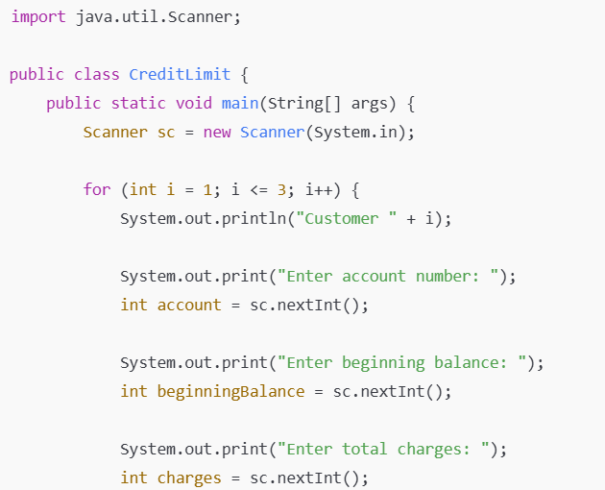
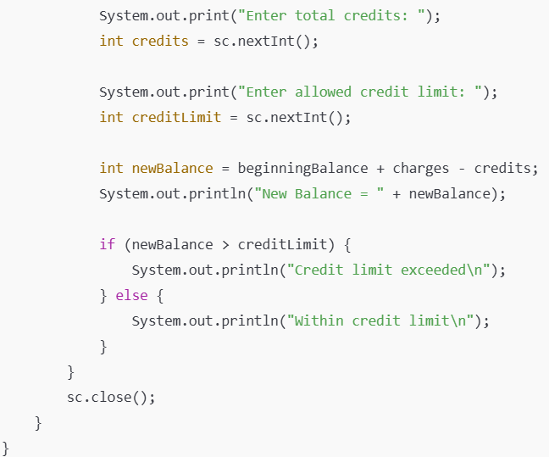
03. What is the difference between a local variable and an instance variable? (1 marks)
Sol^{n}:
Local Variable:
- Declared inside a method/constructor/block.
- Created when method starts and destroyed when method ends.
- Must be initialized before use.
Instance Variable:
- Declared inside class but outside methods.
- Each object has its own copy.
- Created when object is created and destroyed when object is destroyed.
Example:

1  2  3  4  5  6  7  8 | class Student {  String name; // instance variable  void show() {  int age = 20; // local variable  System.out.println(name + " " + age);  }  }

04. Where does array stored in memory? (1 marks)
Sol^{n}:
Java arrays are stored in heap memory because they are objects.

05. What is ArrayIndexOutOfBounds? (1 marks)
Sol^{n}:
ArrayIndexOutOfBoundsException is a runtime exception that occurs when we try to access an array element using an invalid index. If you try to access an index less than 0 or greater than or equal to length, Java will throw an ArrayIndexOutOfBoundsException.
Example:
1  2  3  4  5  6  7  8  9  10 | class Example {  public static void main(String[] args) {  int[] nums = {  1,  2,  3  };  System.out.println(nums[3]); // invalid index, causes exception  }  }

06. Factorials are used frequently in probability problems. The factorial of a positive integer n (n!) is equal to 1×2×…×n. Write an application that calculates factorials of 1 through 20 using long. Display results in tabular format. What difficulty might prevent you from calculating factorial of 100? (2 marks)
Sol^{n}:
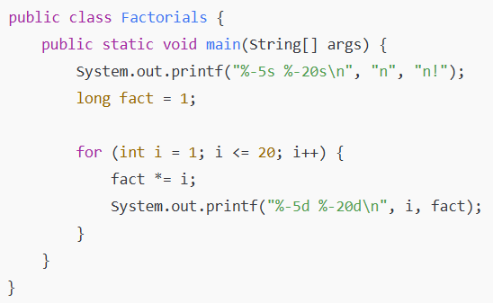
Difficulty for 100!
- long cannot store such a huge number (100! ≈ 10^158).
- We need to use BigInteger to handle very large values.

07. Explain the purpose of a method parameter. What is the difference between a parameter and an argument? (1 marks)
Sol^{n}:
A method parameter is a variable defined in a method’s definition that receives a value when the method is called.
The difference is that a parameter is the variable in the method definition, while an argument is the actual value passed to the method when it is called.
Example:
void greet(String name) { // 'name' is a parameter
System.out.println("Hello " + name);
}

greet("Sakib"); // "Sakib" is an argument

08. (Temperature Conversions)
Implement the following integer methods:
a) Method celsius returns the Celsius equivalent of a Fahrenheit temperature, using the calculation
celsius = 5.0 / 9.0 * (fahrenheit - 32);
b) Method fahrenheit returns the Fahrenheit equivalent of a Celsius temperature, using the calculation
fahrenheit = 9.0 / 5.0 * celsius + 32;
Use these methods from parts (a) and (b) to write an application that enable the user either to enter a Fahrenheit temperature and display the Celsius equivalent or enter a Fahrenheit temperature and display the Celsius equivalent. (3 marks)

Sol^{n}:
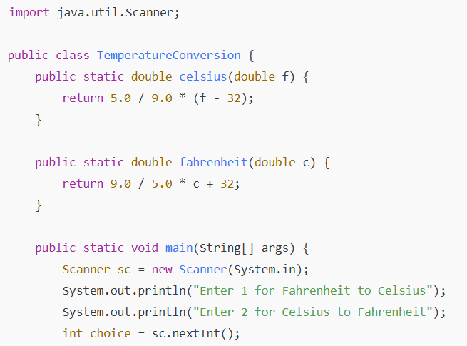
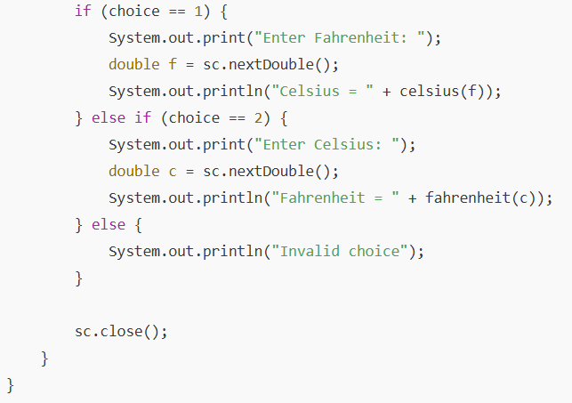

07. What does the following program segment do? (1 marks)
for (i = 1; i <= 5; i++) {
for (j = 1; j <= 3; j++) {
for (k = 1; k <= 4; k++) {
System.out.print("*");
}
System.out.println();
}
System.out.println();
}
Sol^{n}:
It prints a block of stars (*).
- For each outer loop (i from 1 to 5), it prints 3 rows, each with 4 stars.
- After 3 rows, it prints a blank line.
- Total: 5 blocks of 3×4 stars separated by blank lines.
Output (simplified):
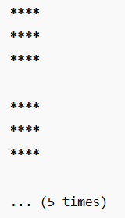

- 10. Identify and correct the errors in each of the following sets of code: (1 marks)
a)
while (c <= 5) {
product *= c;
++c;
}
b)
if (gender == 1)
System.out.println("Woman");
else;
System.out.println("Man");

Sol^{n}:
(a) Correction: Variable c must be initialized before the loop, and product must also be initialized.
(b) Correction: Error was the extra semicolon (;) after else. So, remove the semicolon after else.

